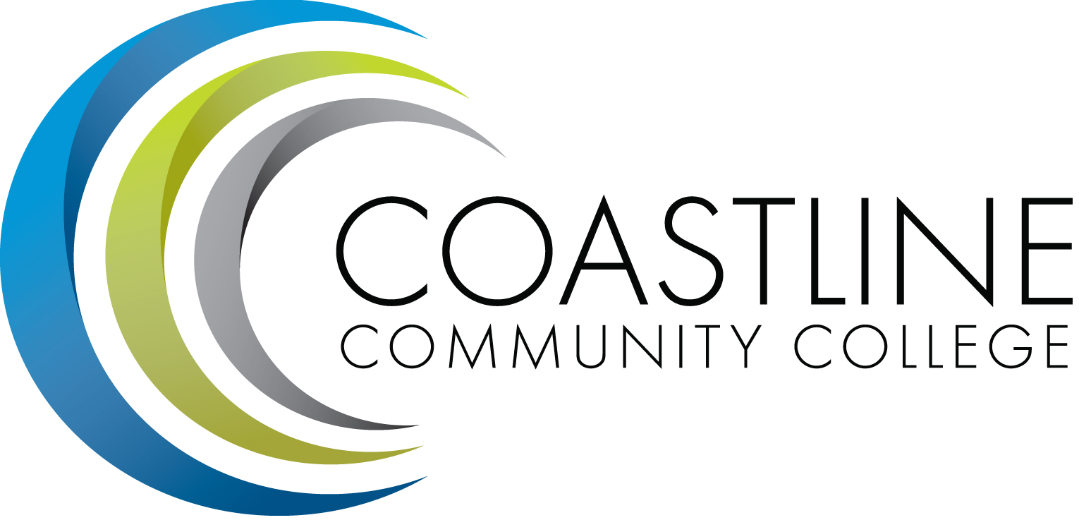

College Professional Development & Leadership Committee Agenda
3/07/2017
3:00 pm to 5:00 pm
College Center, Distance Learning Conference Room

Committee Mandate: To promote, coordinate, recommend, and support the creation and delivery of professional development and leadership programs that increase the effectiveness of our institution and the satisfaction of our employees.
- CALL TO ORDER
  - Roll Call

Present | Members
 | Bob Nash, Co-chair, Associate Dean, Distance Learning & Prof. Development
 | Cheryl Chapman, Co-chair, Academic Senate Representative
 | Mitchell Alves, Faculty Success Center Coordinator
 | Judy Garvey, MECTBD Administrator Representative
ABS | Elaine Hill, Classified Senate Representative
 | Ken Leighton, Academic Senate Representative
 | Dorothy McCollom, Classified Senate Representative & Committee Support
 | Renate Akins, Director of HR
ABS | Araba Mensah, Classified Senate Representative
 | Randall Warwick, Academic Senate Representative

  - Welcome
  - Adoption of Agenda
  - Approval of Minutes: 2/07/2017

- SPECIAL REPORTS & UPDATES
  - None

- ACTION ITEMS
  - None

- STANDING REPORTS
  - Cornerstone Update – Renate
  - Faculty Success Center (FSC) Update – Cheryl

- DISCUSSION ITEMS
  - All-College Spring Workshop Update (April 14, 2017)
    - Canvas – General Information for Classified
    - SharePoint – General Information for Classified
    - Onboarding
  - Daniel Pittaway’s Request ($1,500) for Mini-Workshop on “Growth Mindset and Habits of Mind”
  - Elizabeth Horan’s Request ($500) for Mini-Workshop titled “Creating Faculty Webpages with the Canvas ePortfolio”

- ANNOUNCEMENTS (1-2 minutes per)
  - Next Meeting, April 4, 2017 at 3:00 pm

- ADJOURNMENT

